HICP Dashboard
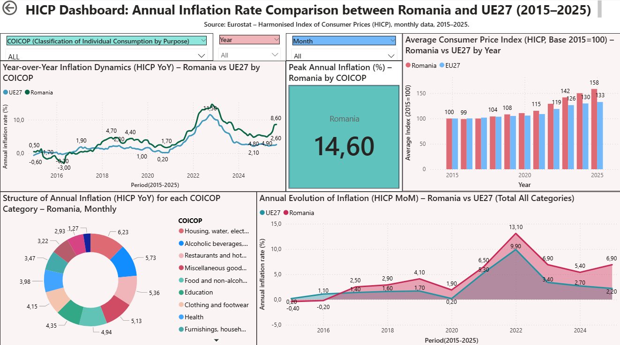
Annual Inflation Rate Comparison between Romania and UE27 (2015–2025)

Slicers influencing this visual:
- COICOP Category
- Year
- Month

Line Chart – Annual Inflation Rate (HICP YoY) – Romania vs EU27 by Category
Description:
The chart presents the annual evolution of inflation rates (Year-over-Year, YoY) for Romania compared to the EU27 average between 2015 and 2025. The data can be filtered by COICOP category (type of consumption expenditure) and Year. The line chart shows how the annual inflation rate evolved in Romania versus the EU average, for a selected consumption category (e.g., food, housing, education). Peaks in the curve indicate years with the highest inflation pressure for that category.

Card – Peak Annual Inflation (HICP YoY) – Romania
Description:
This card displays the maximum annual inflation rate (YoY) recorded in Romania between 2015 and 2025 for the selected COICOP category. It provides an at-a-glance indicator of the inflation peak during the period. It helps identify the highest inflation level reached in Romania for each consumption category, allowing quick comparisons between sectors and timeframes.

Clustered Column Chart – Average HICP (Base Year 2015=100) – Romania vs EU27
Description:
This chart illustrates the average Consumer Price Index (HICP) for Romania and the EU27, expressed relative to the base year 2015 (set to 100). It highlights the cumulative price growth since 2015 rather than the percentage change.

Donut Chart – Monthly Structure of Inflation (HICP YoY) by COICOP – Romania
Description:
The pie chart presents the composition of inflation (YoY) for Romania, showing the share of each COICOP category in total inflation for the selected month. Each slice represents the proportion of inflation generated by a specific type of expenditure.

Area Chart – Monthly Inflation Rate (HICP MoM) – Romania vs EU27 (All Categories)
Description:
This chart shows the month-over-month (MoM) rate of inflation for all consumption categories combined, comparing Romania with the EU27. It reflects short-term changes in inflation dynamics. It captures monthly volatility in inflation and highlights the periods with the strongest fluctuations, such as energy crises or post-pandemic rebounds.
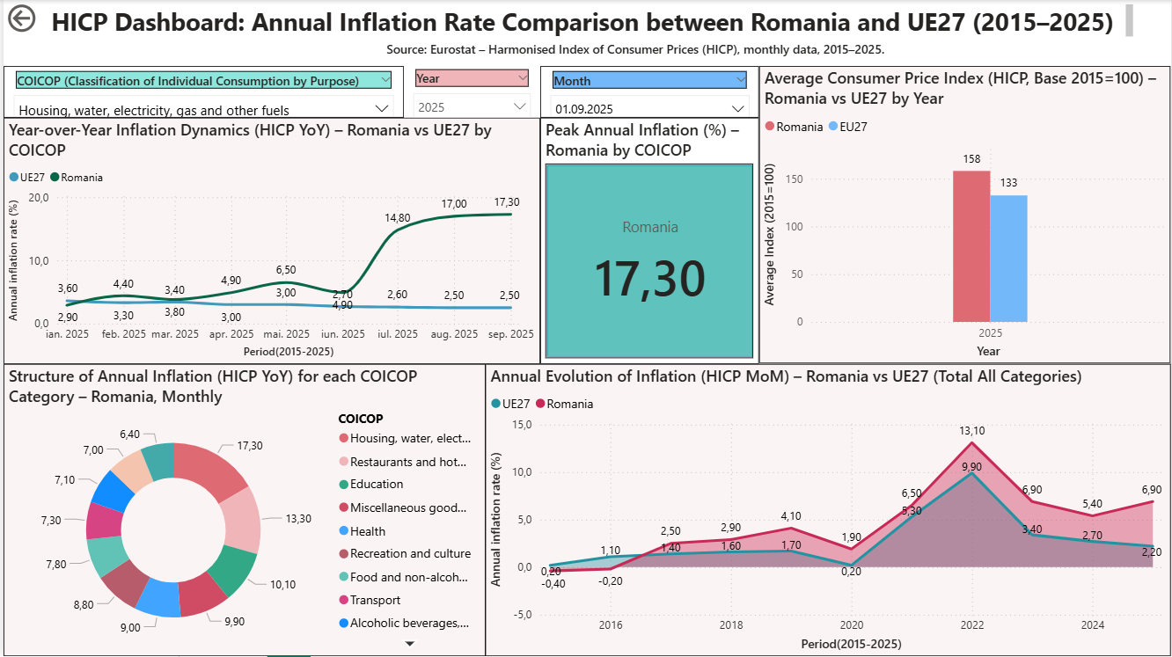
Exemple:

For a more recent exemple, in September 2025, inflation in Romania reached 17.3% in the housing, water, electricity, gas and fuels category — the highest value recorded since 2015. This strong price growth was mainly driven by rising energy and utility costs, amplified by global energy market pressures and domestic supply constraints. Compared to the EU27 average of around 2.5%, Romania’s inflation remains significantly above the European benchmark, reflecting structural price rigidity in non-competitive sectors. The Consumer Price Index (Base 2015=100) shows Romania at 158, versus 133 for the EU, illustrating a faster cumulative price increase since 2015. The monthly inflation trend (HICP MoM) indicates stabilization after the 2022 peak but persistent volatility. Overall, Romania faces sustained cost-push inflation, underscoring the need for improved energy efficiency and fiscal coordination to curb long-term price instability.

